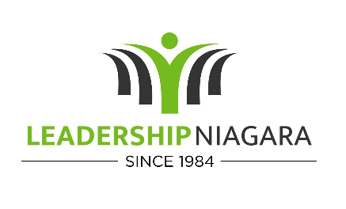
2025 Session Dates
January 17 -18
Opening Retreat - Overnight
February 13
Manufacturing Day
March 13
Education Day
April 10
Diversity, Equity & Inclusion Day
May 15
Healthcare Day
June TBA – (Tentatively 12 &13)
Mid-Year Overnight Retreat (NFARS)
Military Affairs
Community Action Projects
July 17
Tourism Day
August 14
Criminal Justice Day
September 11
Economic Development
October 16
Agribusiness Day
November 13
Closing retreat
Project Presentations
December 11
LN Graduation

